
Department of Computer Science and Engineering DevOps Lab - L3

Lab Assignment No: 11
Name of Student | Atharva Rale
PRN | 23070122174
Batch | 2023 – 2027
Class | CSE – B1
Academic Year & Semester | 2026 - 2027, 7th Semester
Title of Assignment | Docker Compose for Multi-Container App
Implementation & Theory | Project directory + base files — Created my-multi-app and carried over the Flask app, requirements, and Dockerfile from the earlier volumes assignment as a starting point.  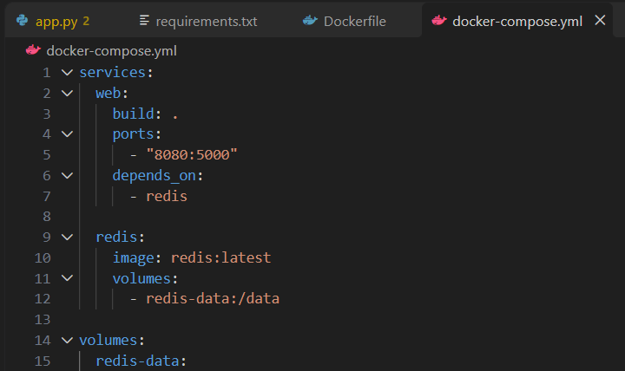  app.py updated for Redis — Modified the Flask app to connect to a Redis service (hostname redis, the Compose service name) and  increment a hits counter on every request, returning the current count.

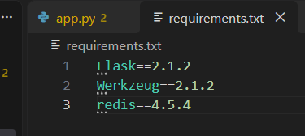
requirements.txt updated — Added redis==4.5.4 as a dependency alongside the existing Flask/Werkzeug pins.

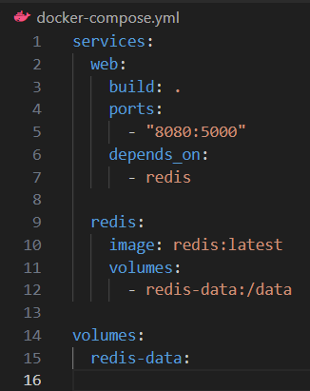
docker-compose.yml created — Defined two services: web (built from the local Dockerfile, mapped to host port 8080) and redis (official Redis image, with a named volume redis-data for persistence). depends_on ensures Redis starts before the web service.

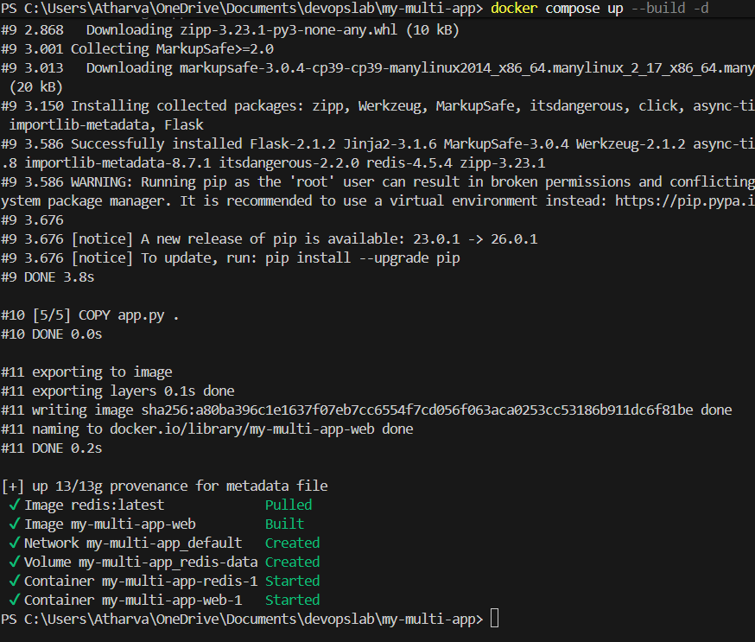
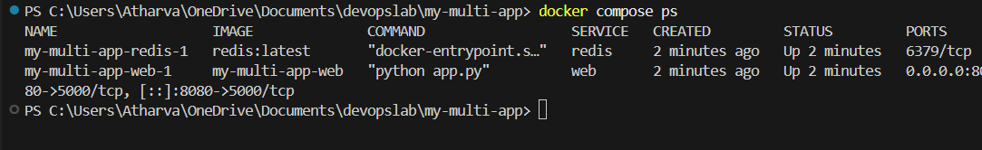
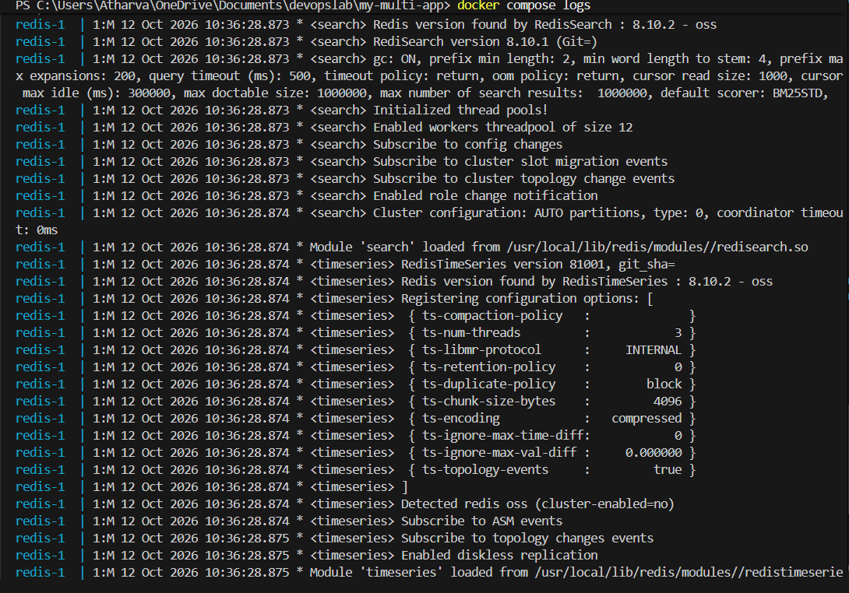
Multi-container app started — Ran docker-compose up; logs showed both the web and redis containers building/starting and joining the same Compose-managed network.

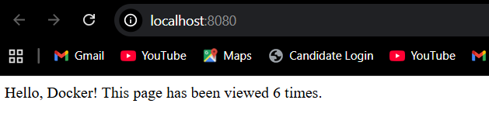

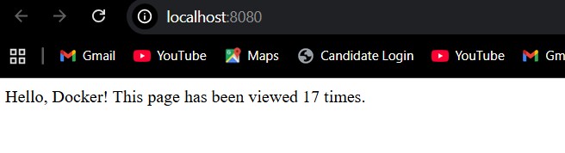

Cross-service communication verified — Accessed http://localhost:8080 and refreshed repeatedly; the hit counter incremented on each request, confirming the web container successfully reached redis over the internal Docker network using the service name as hostname.

Teardown — Ran docker-compose down to stop and remove the containers and network (volume retained by default).

